Evaluation Warning: The document was created with Spire.Doc for JAVA.

Evaluation Warning : The document was created with Spire.PDF for java.

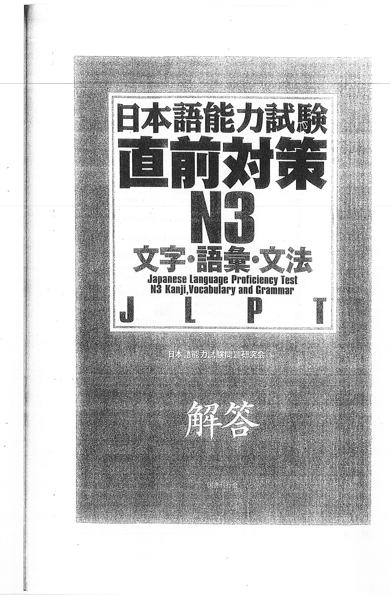

Evaluation Warning : The document was created with Spire.PDF for java.

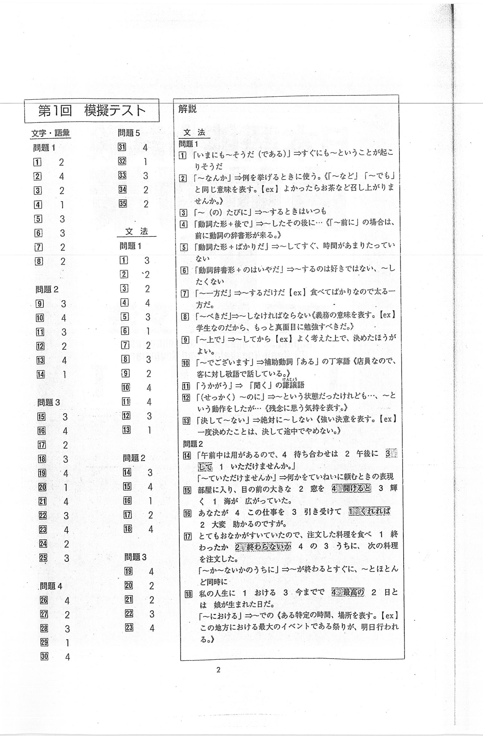

Evaluation Warning : The document was created with Spire.PDF for java.

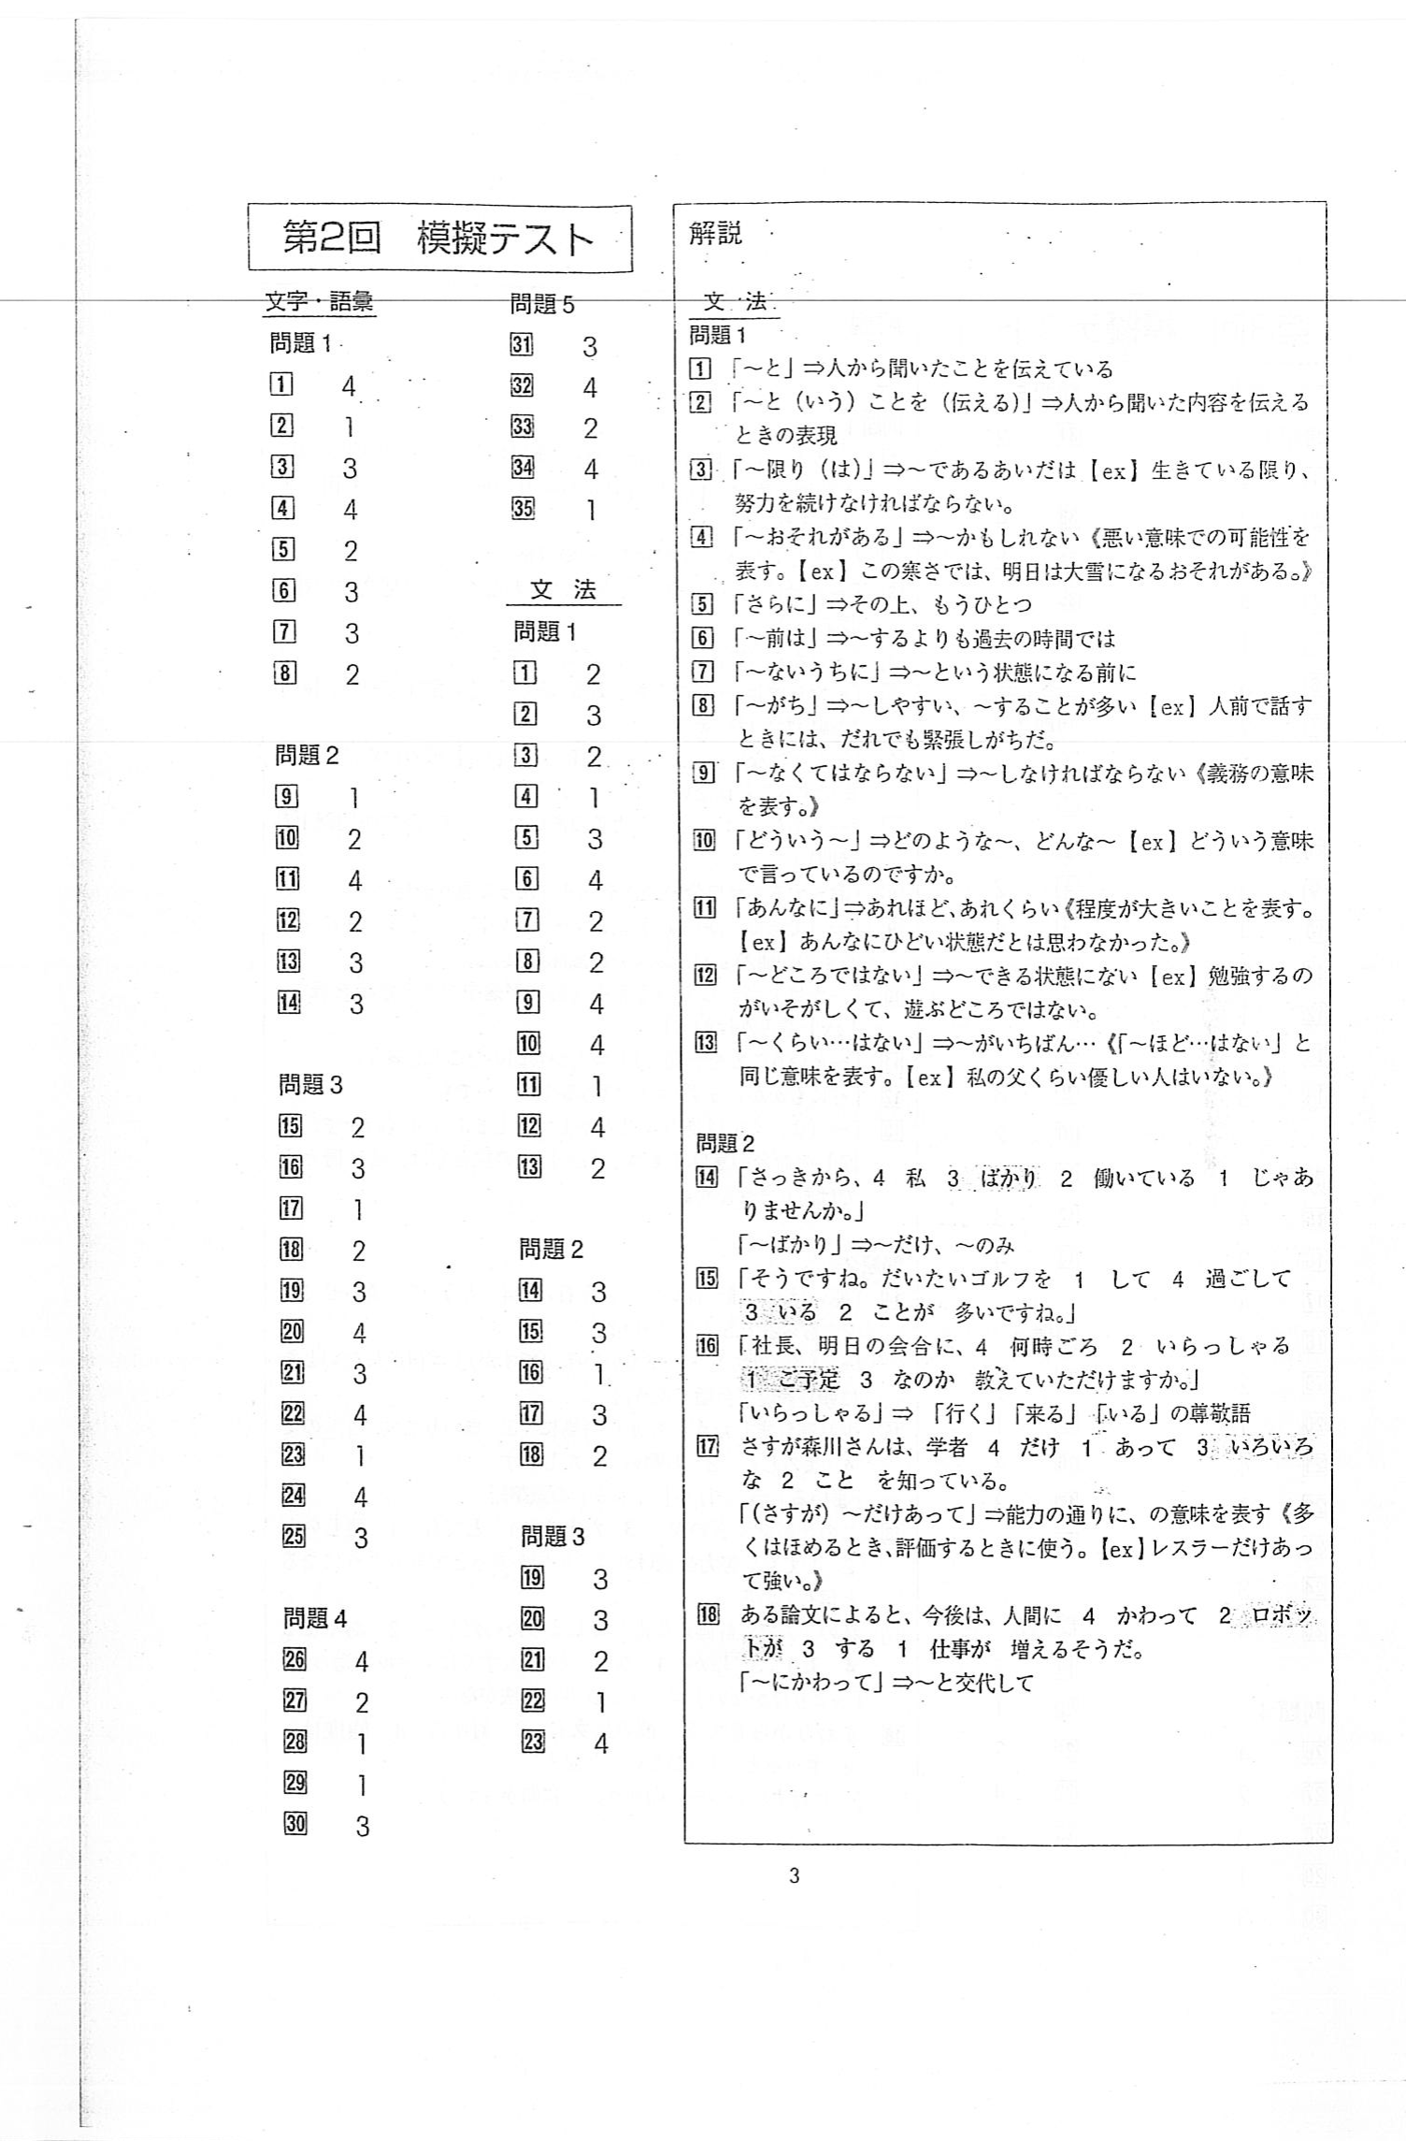

Evaluation Warning : The document was created with Spire.PDF for java.

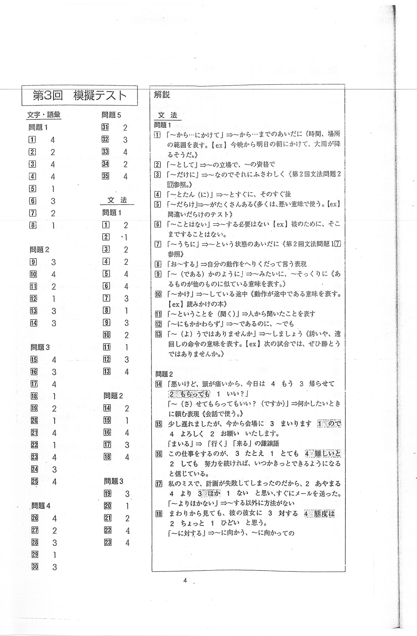

Evaluation Warning : The document was created with Spire.PDF for java.

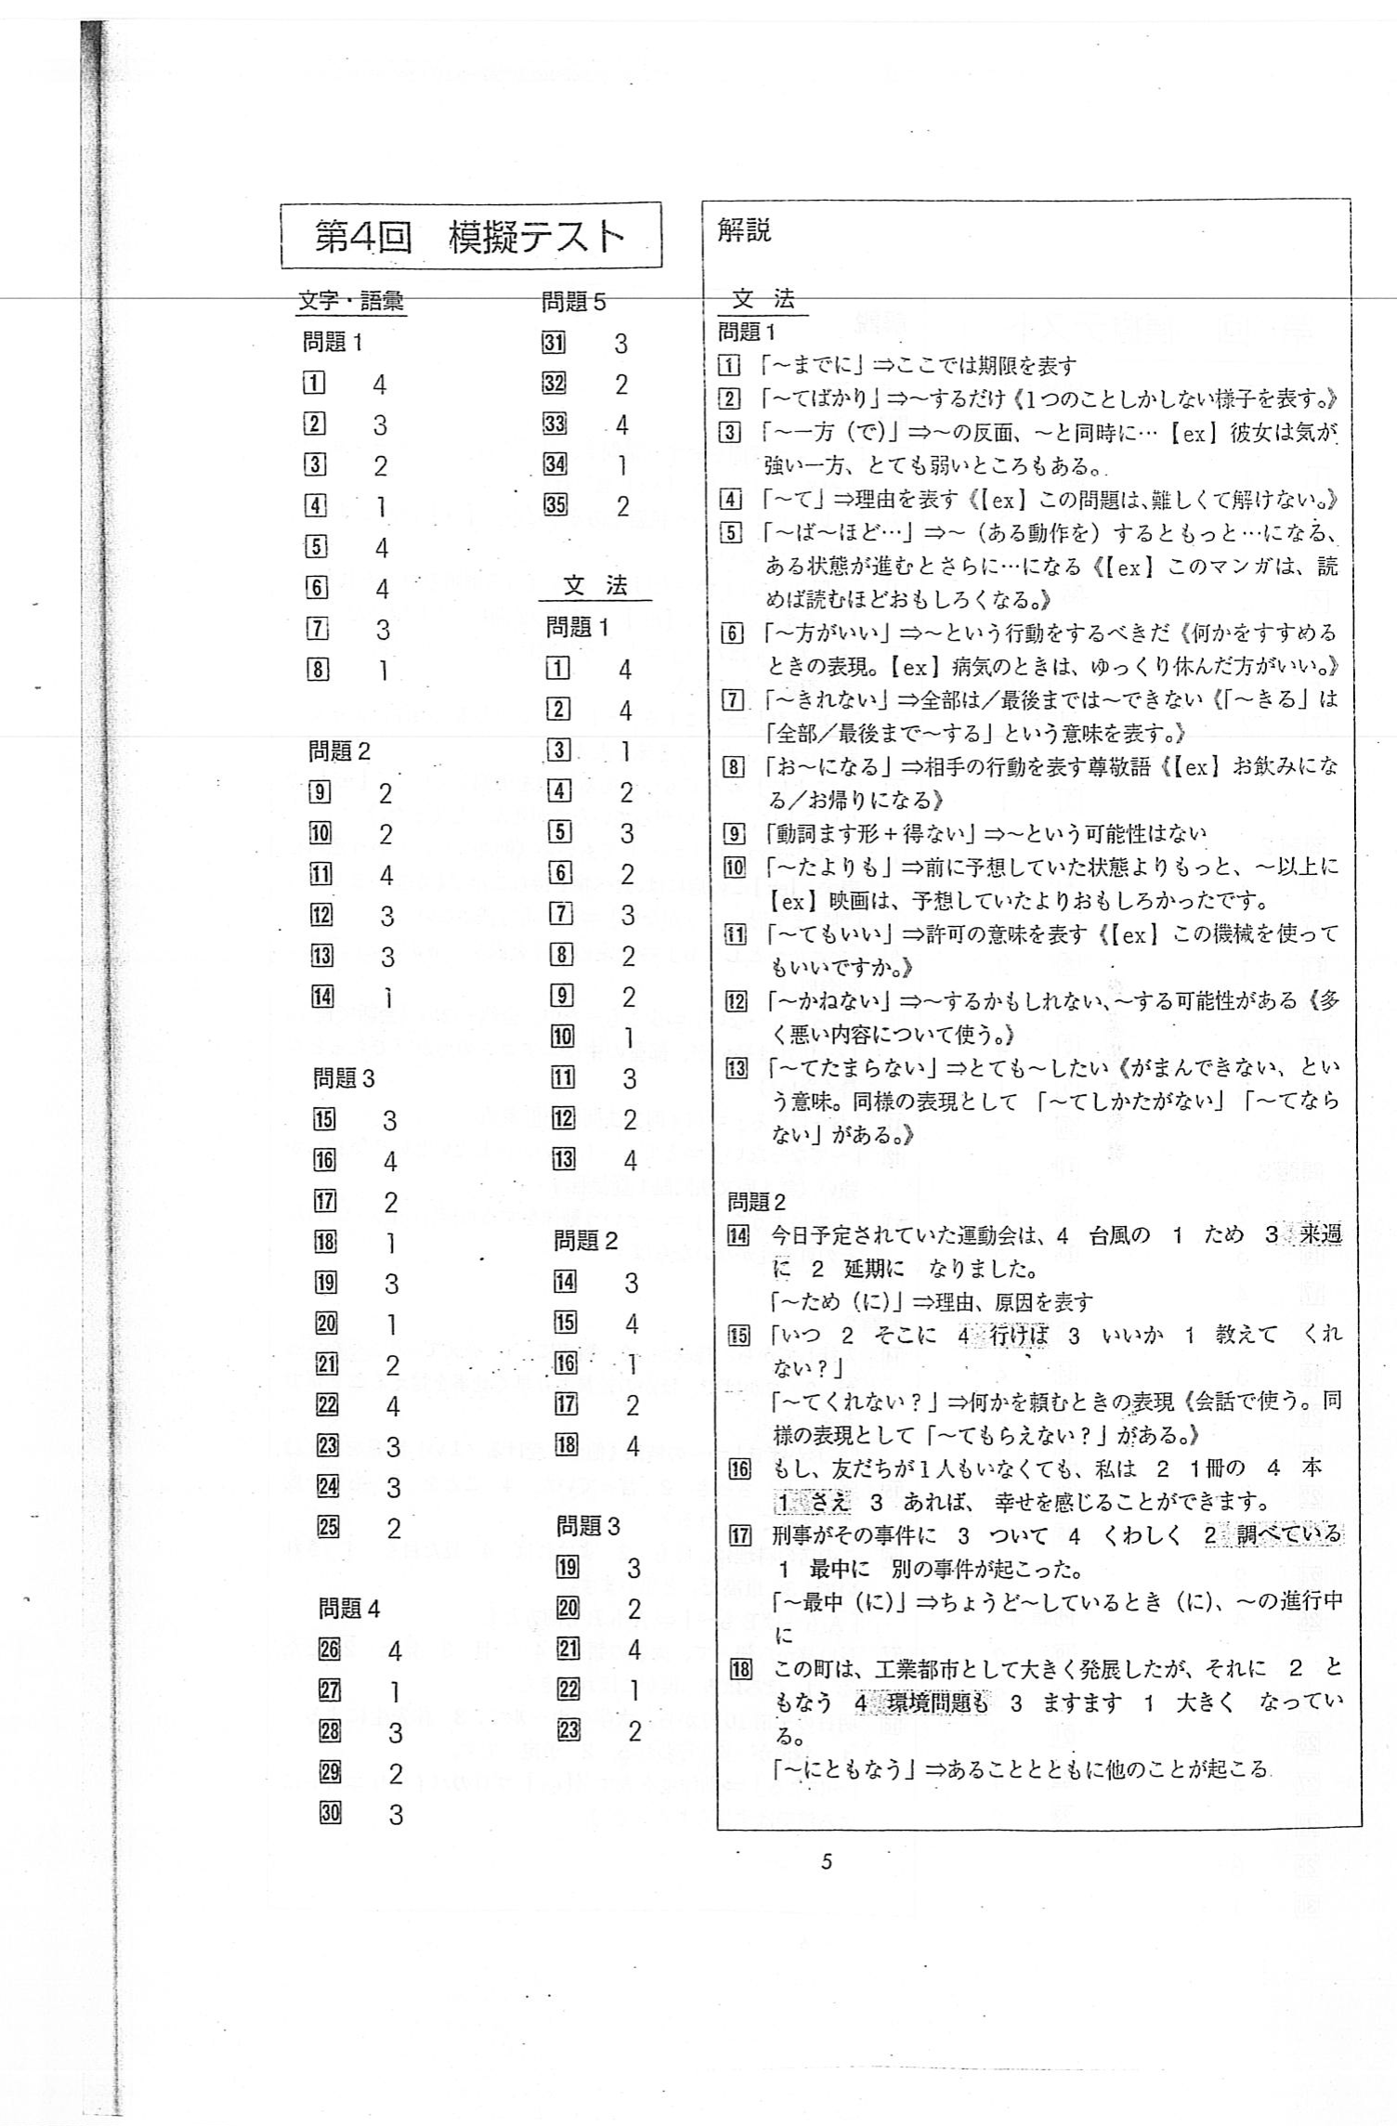

Evaluation Warning : The document was created with Spire.PDF for java.

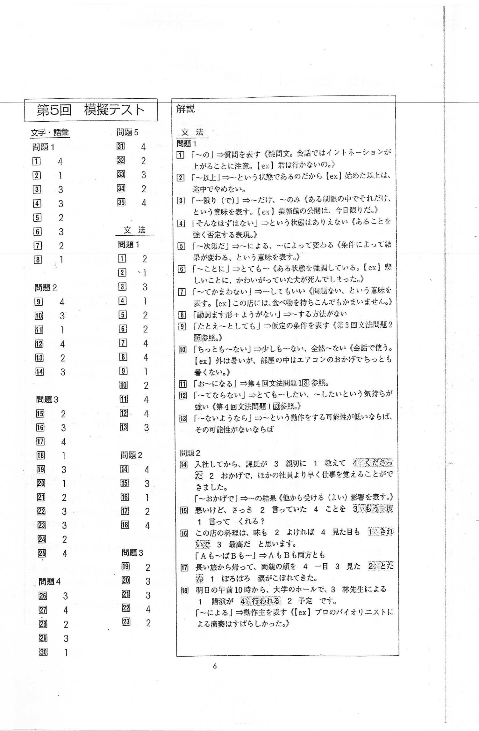

Evaluation Warning : The document was created with Spire.PDF for java.

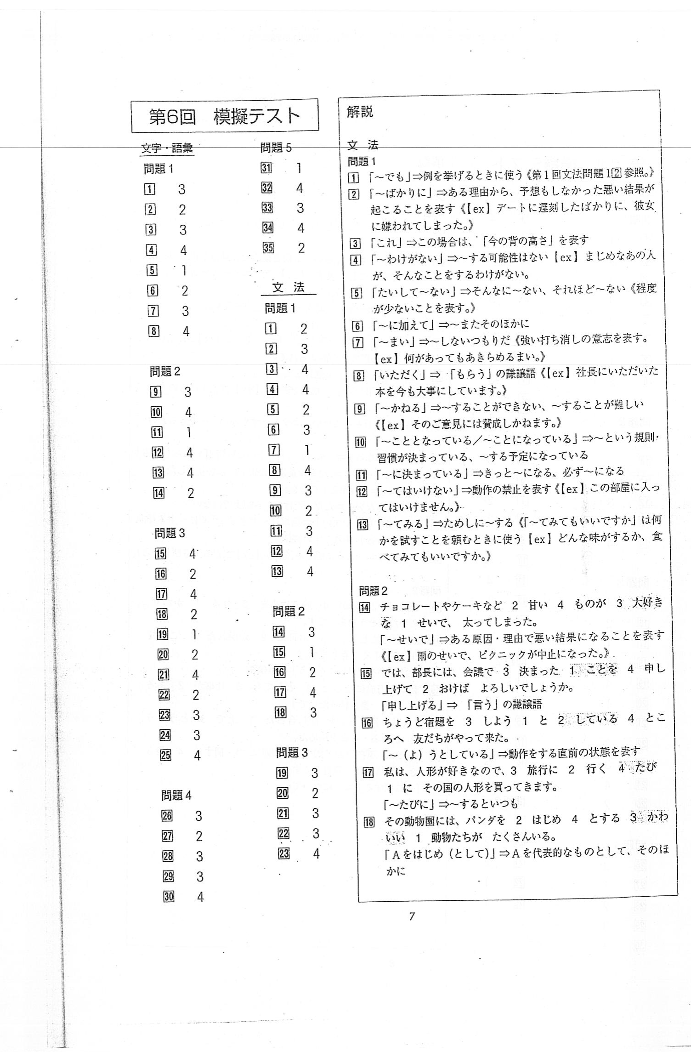

Evaluation Warning : The document was created with Spire.PDF for java.

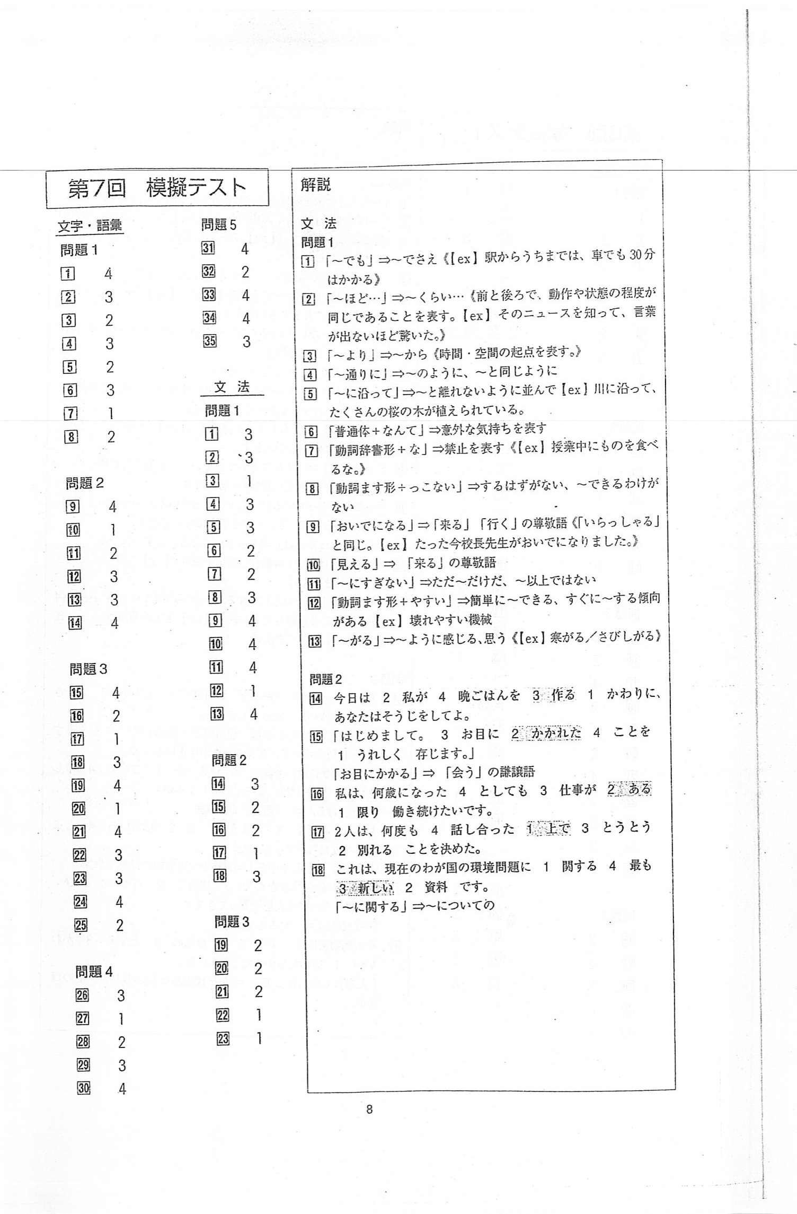

Evaluation Warning : The document was created with Spire.PDF for java.

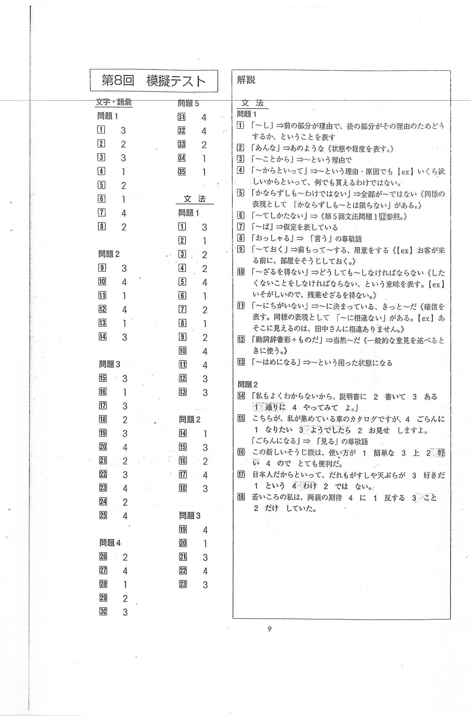

Evaluation Warning : The document was created with Spire.PDF for java.

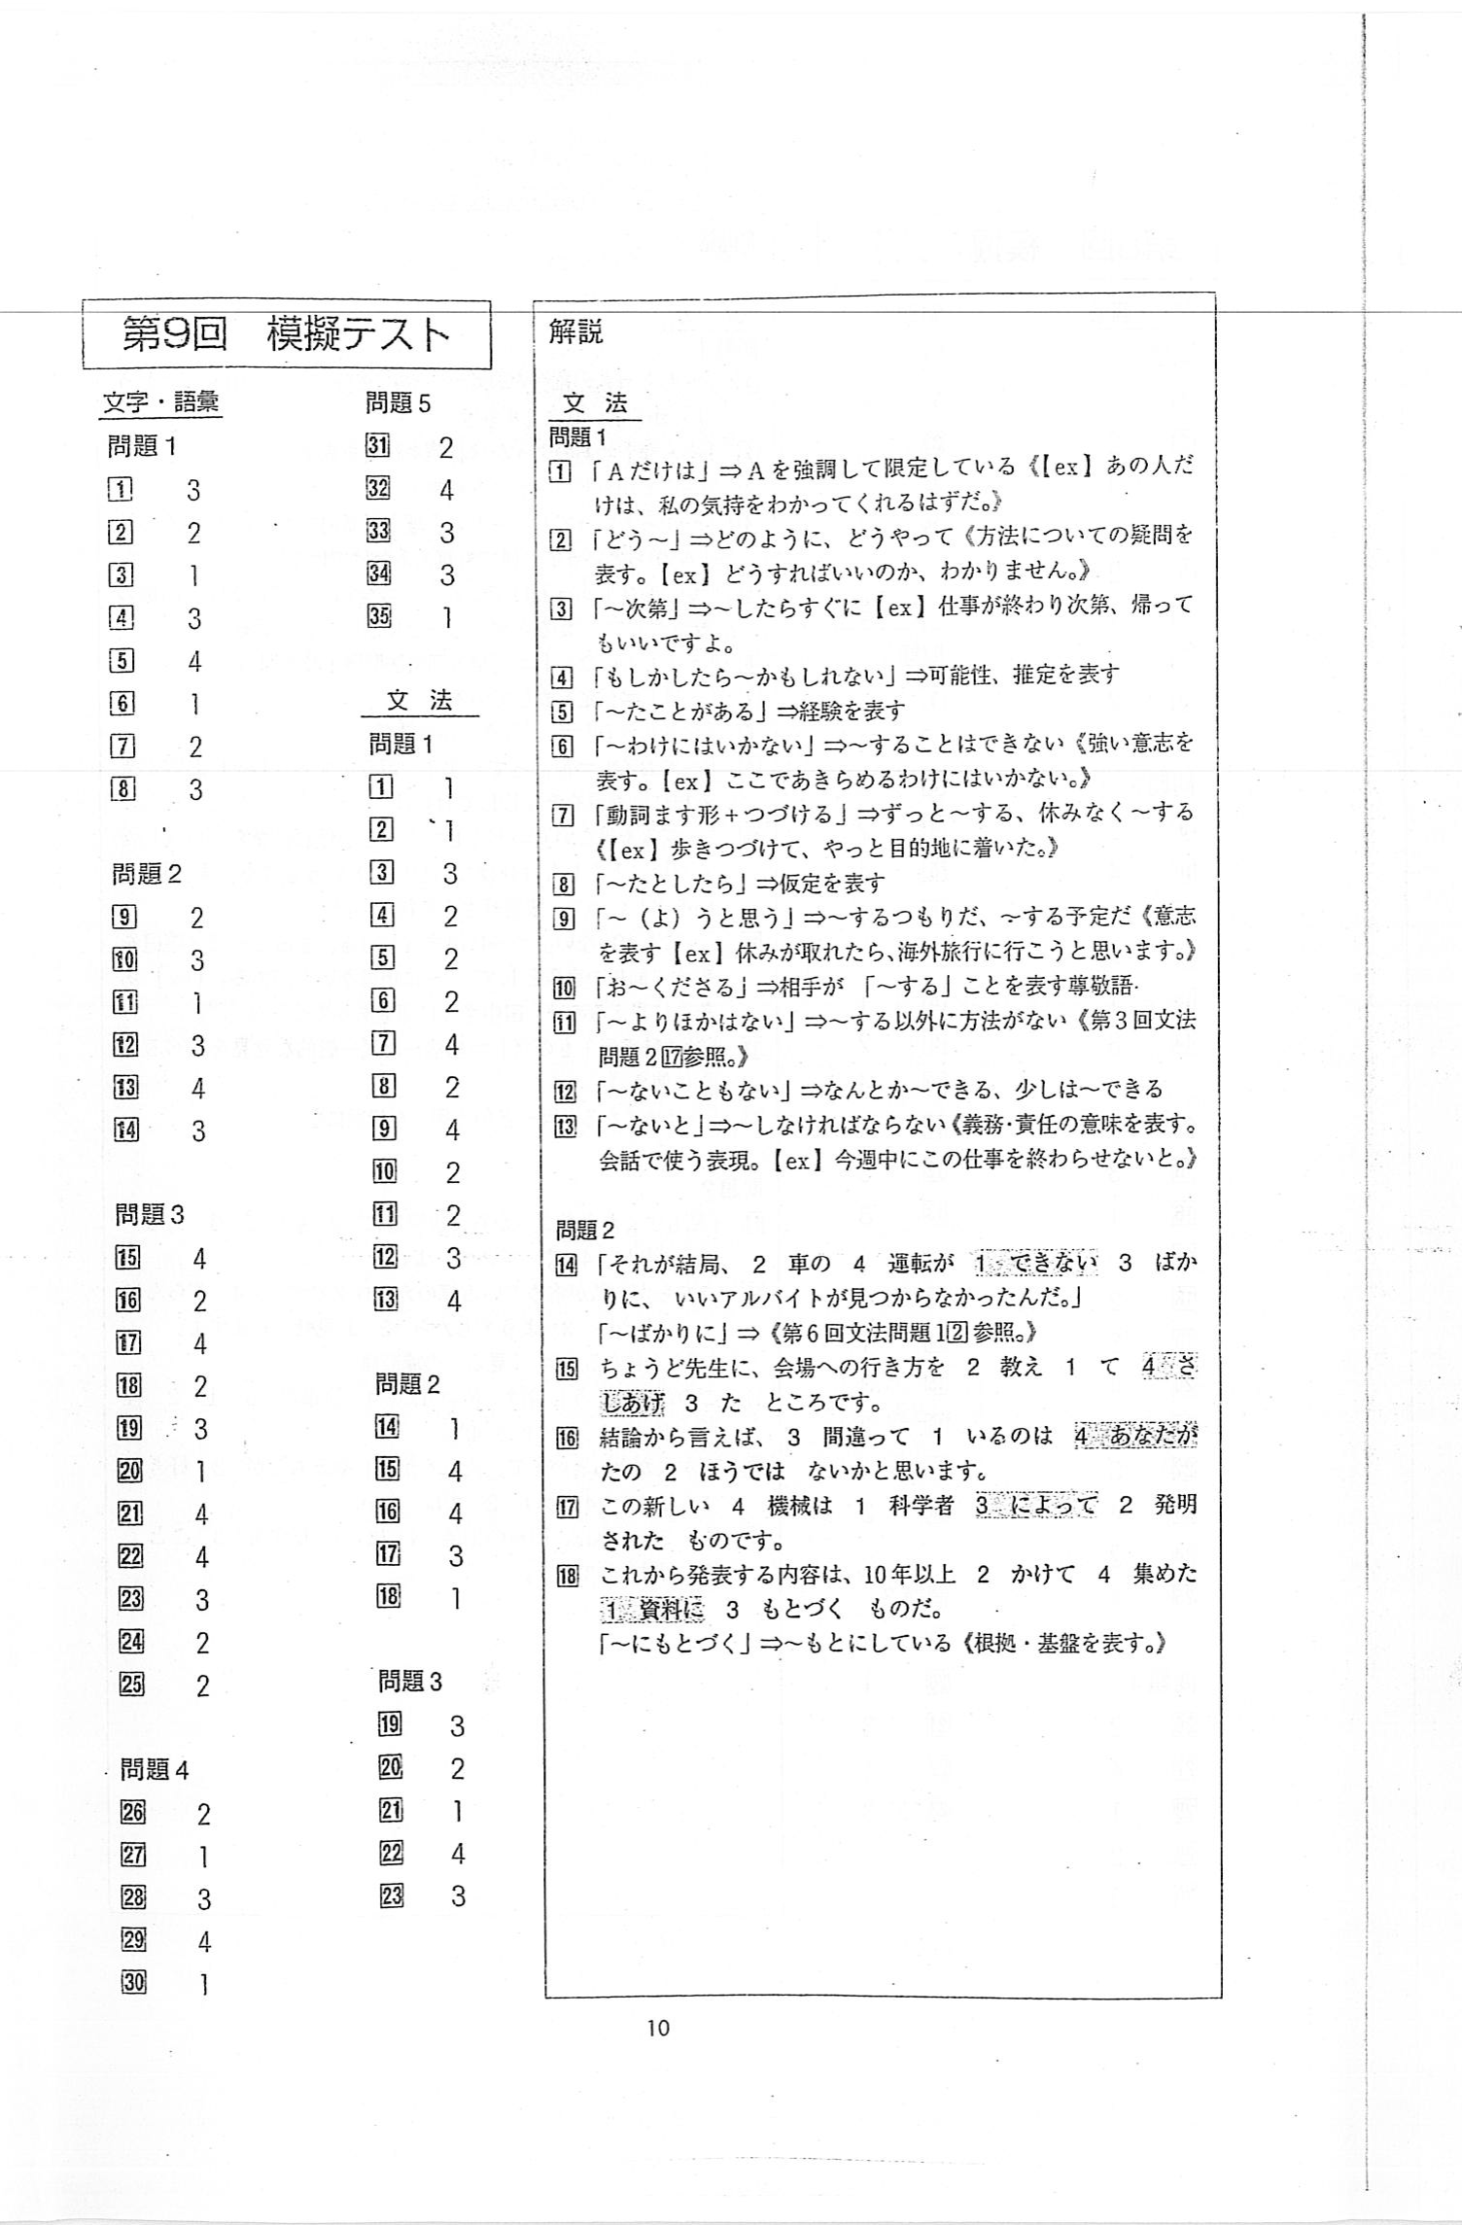

Evaluation Warning : The document was created with Spire.PDF for java.

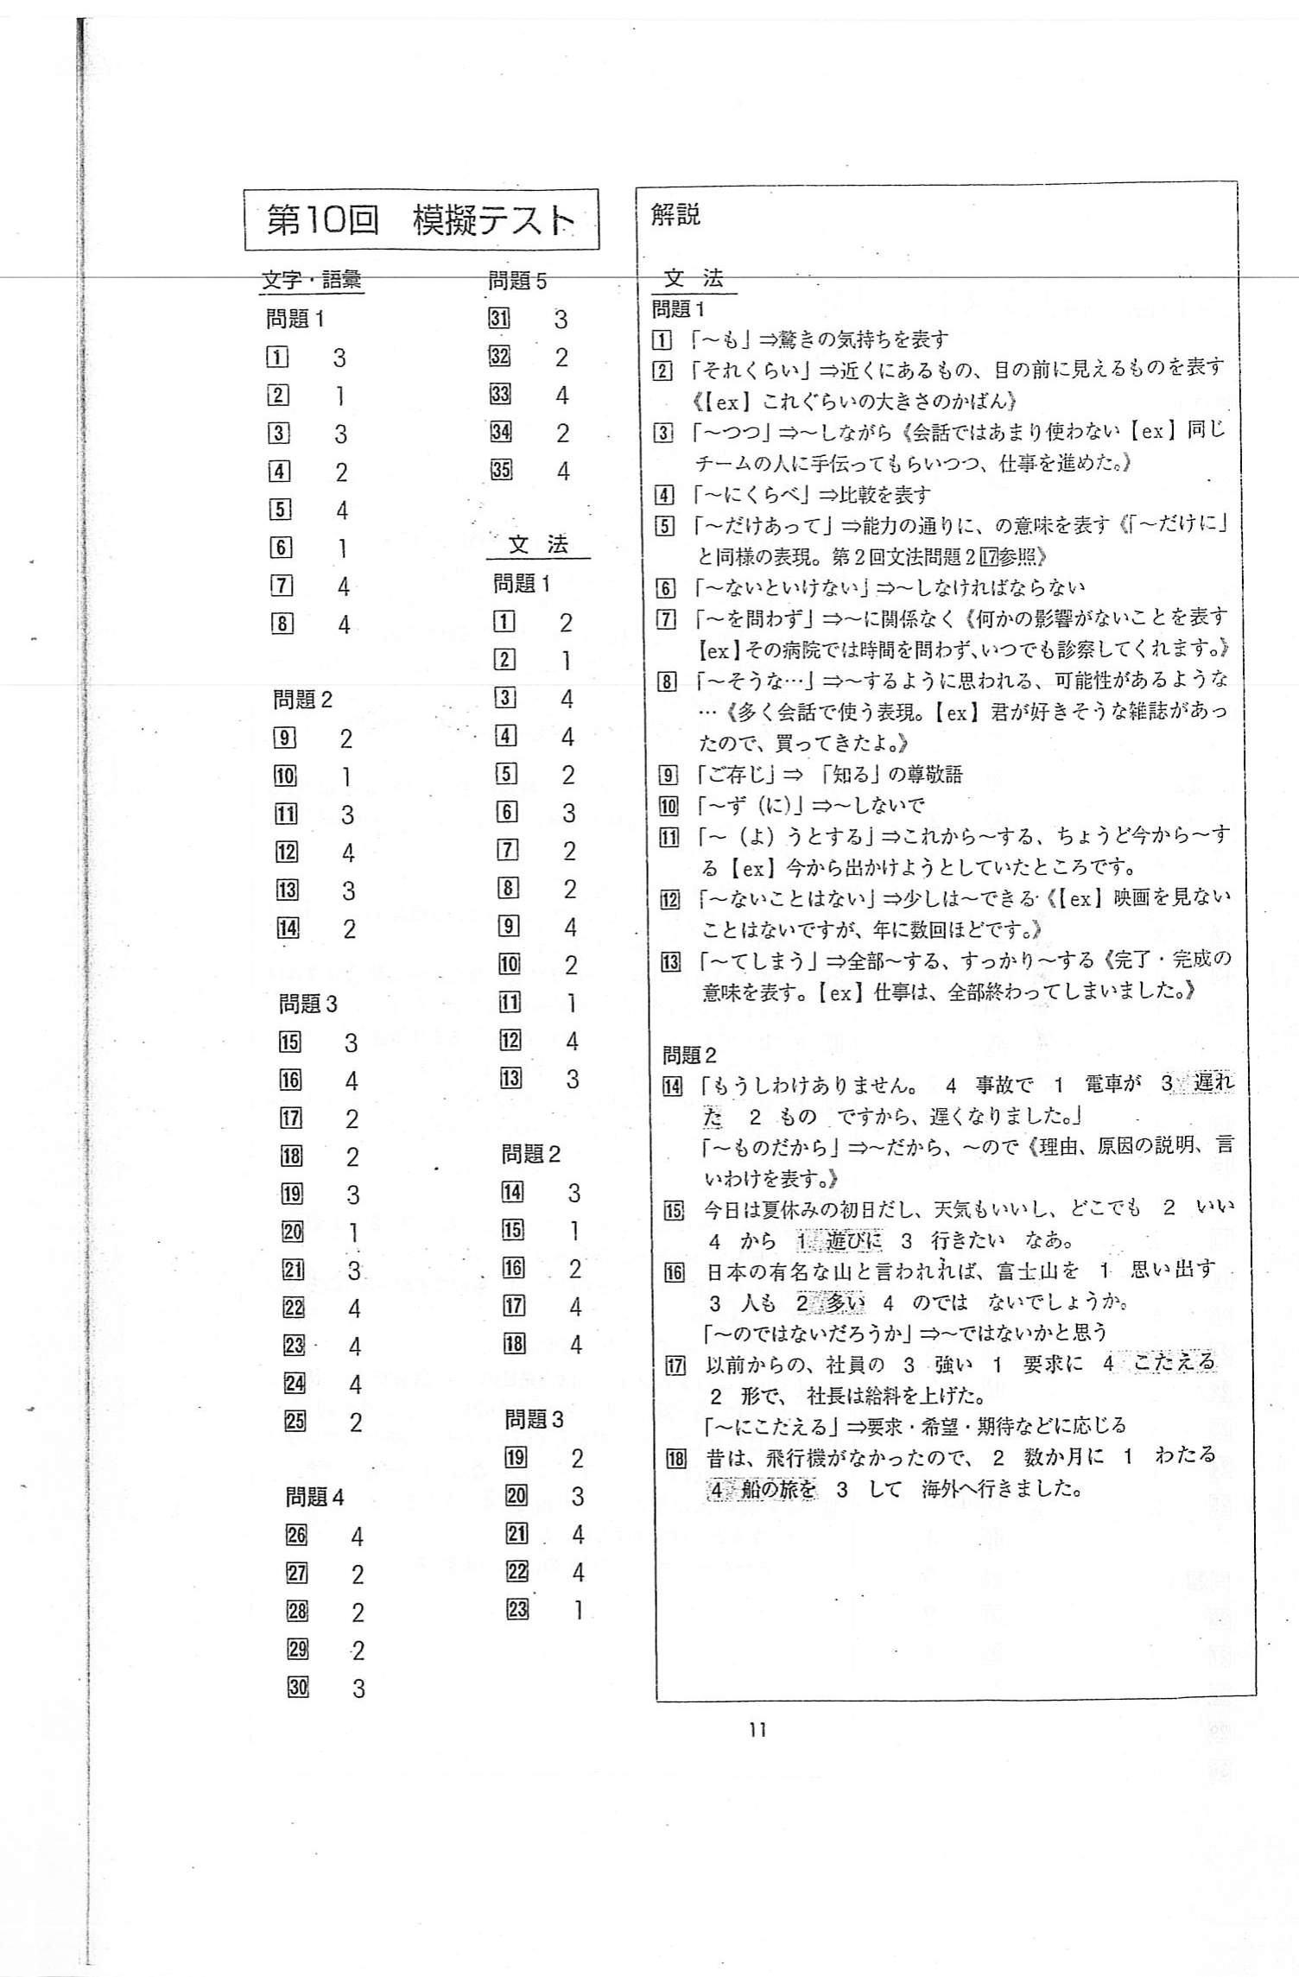

Evaluation Warning : The document was created with Spire.PDF for java.

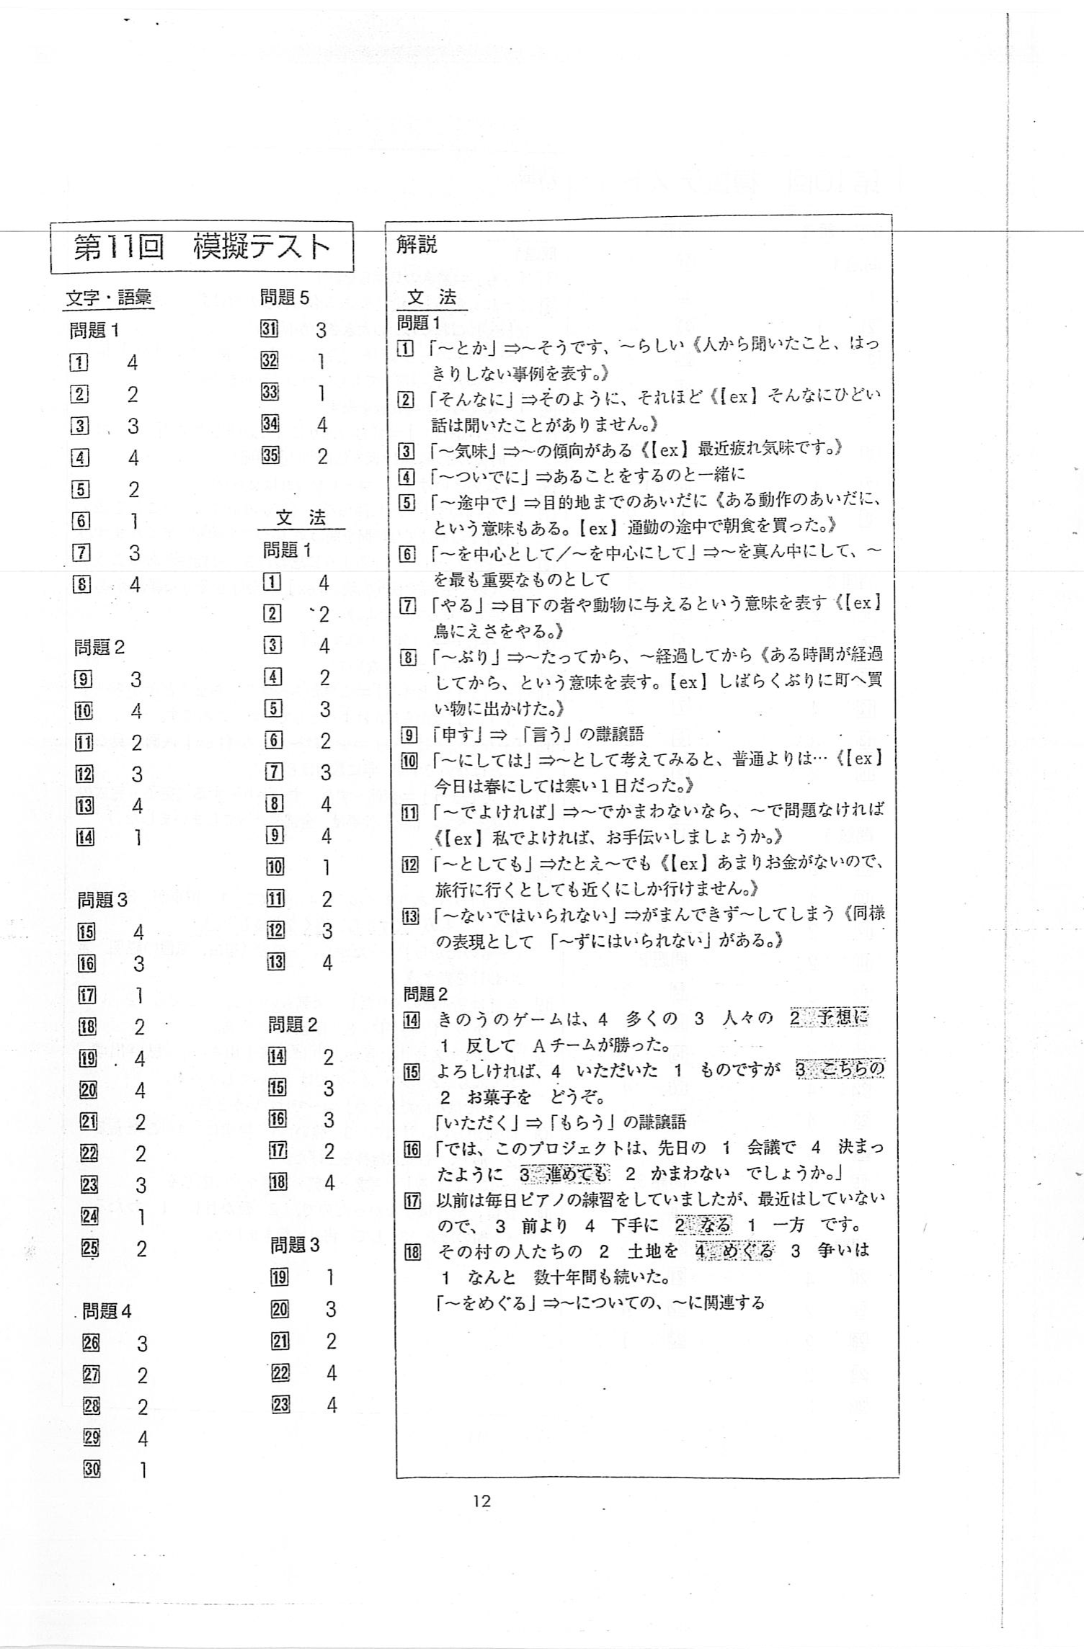

Evaluation Warning : The document was created with Spire.PDF for java.

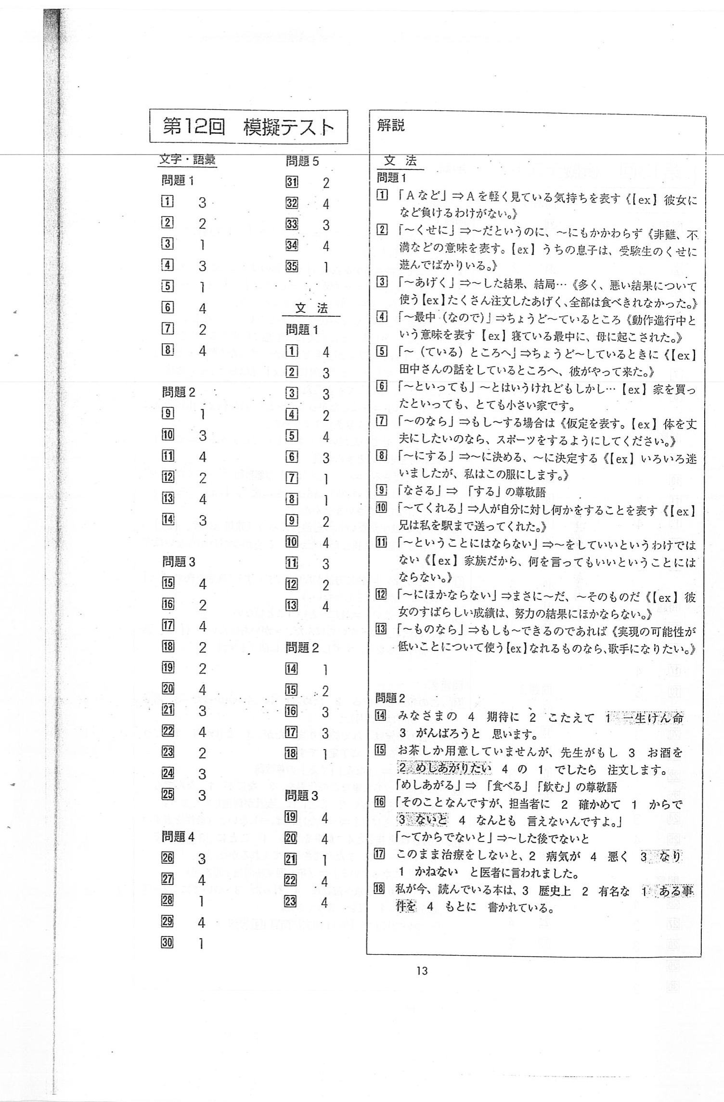

Evaluation Warning : The document was created with Spire.PDF for java.

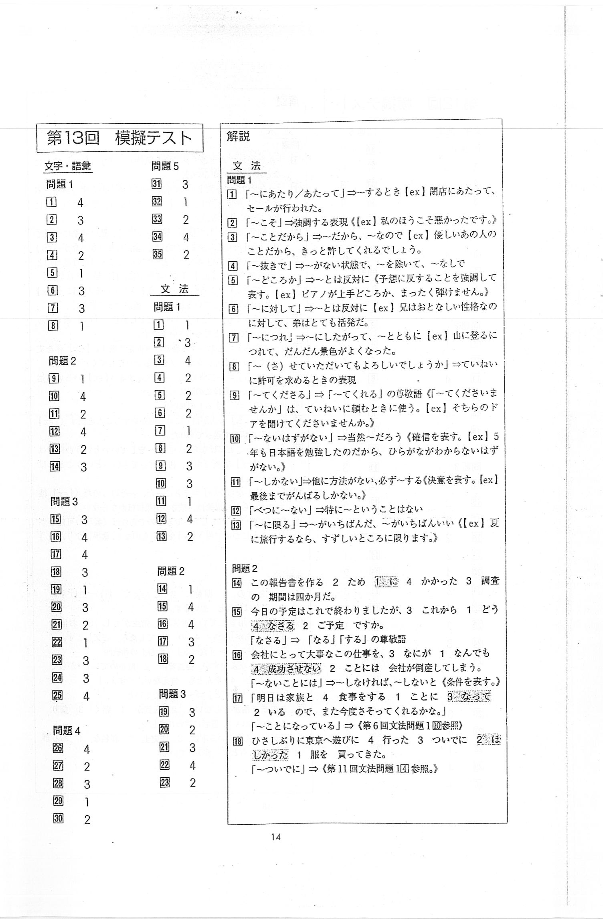

Evaluation Warning : The document was created with Spire.PDF for java.

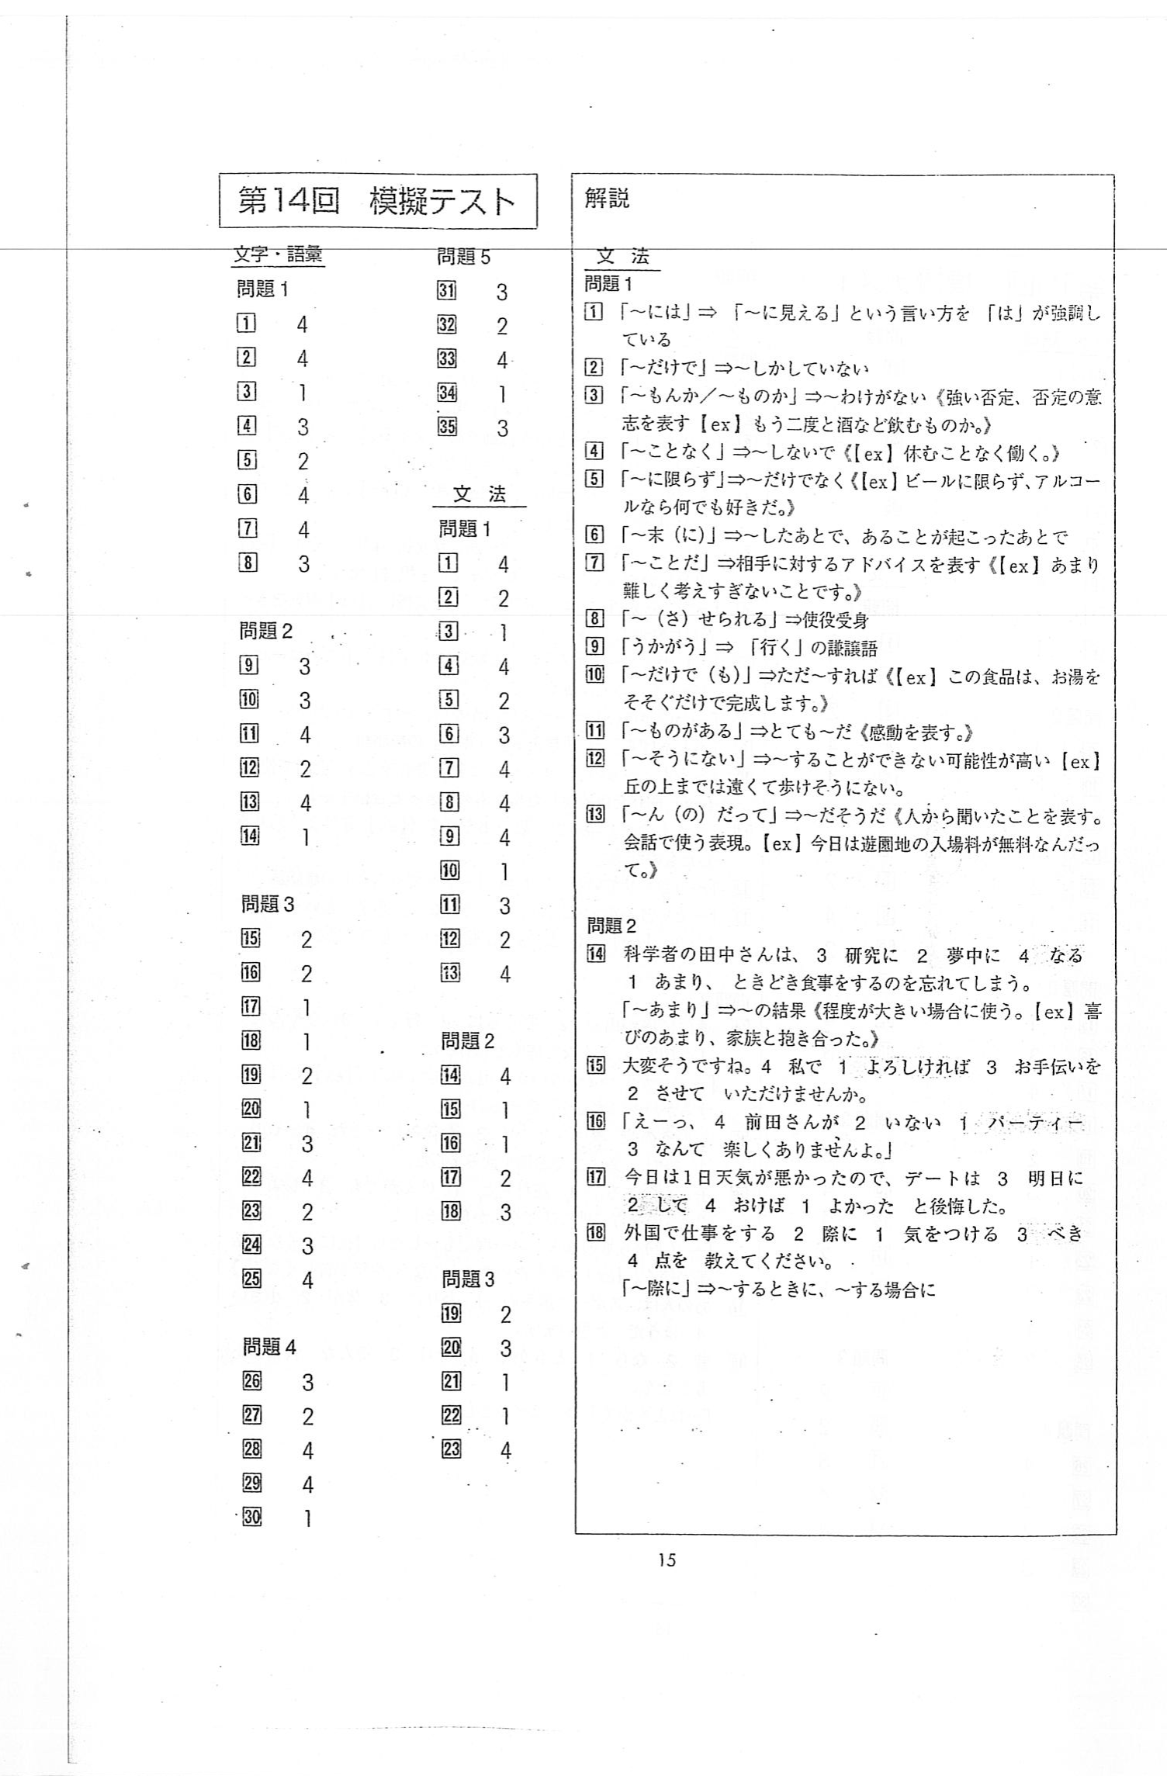

Evaluation Warning : The document was created with Spire.PDF for java.

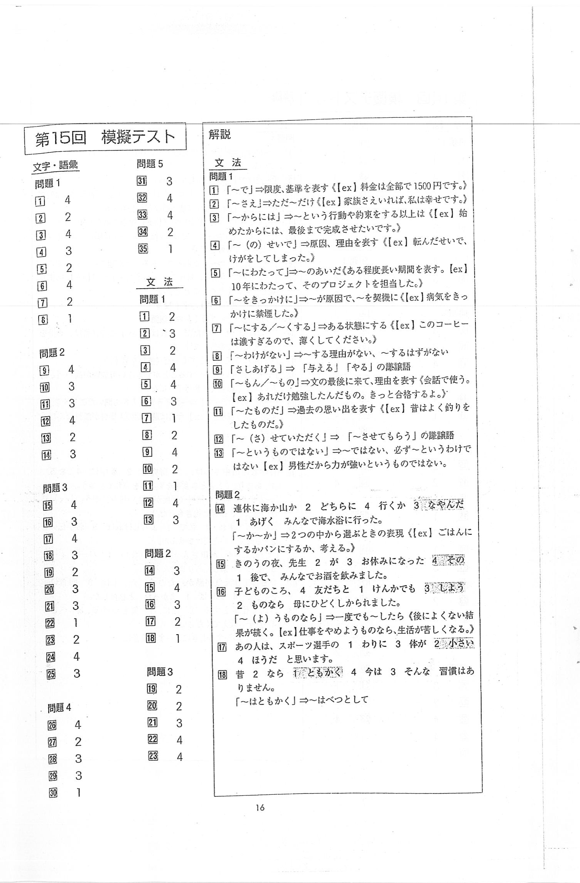

Evaluation Warning : The document was created with Spire.PDF for java.

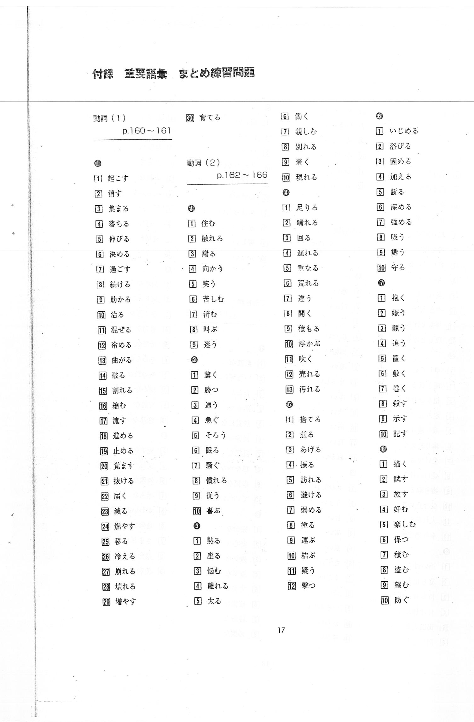

Evaluation Warning : The document was created with Spire.PDF for java.

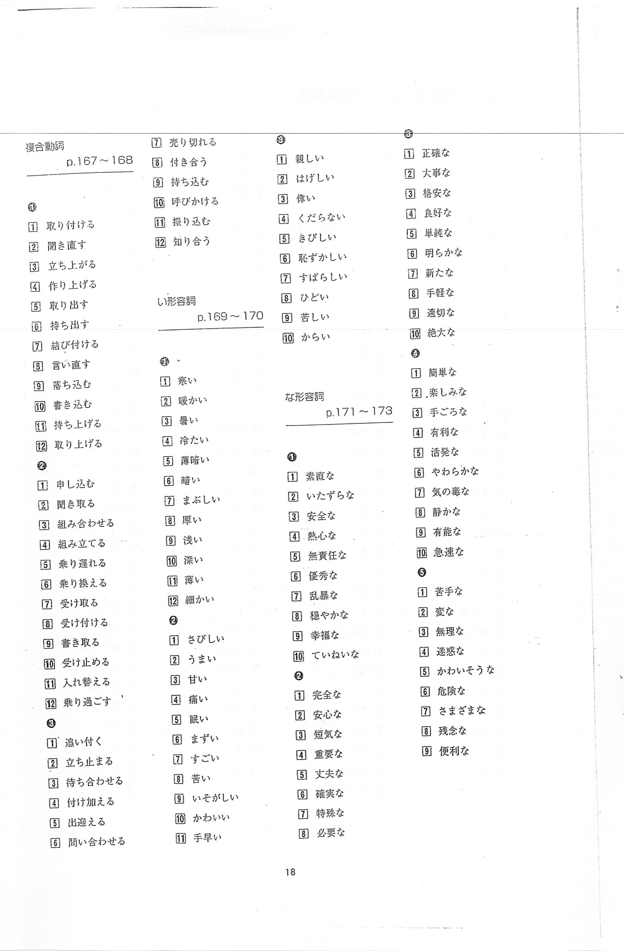

Evaluation Warning : The document was created with Spire.PDF for java.

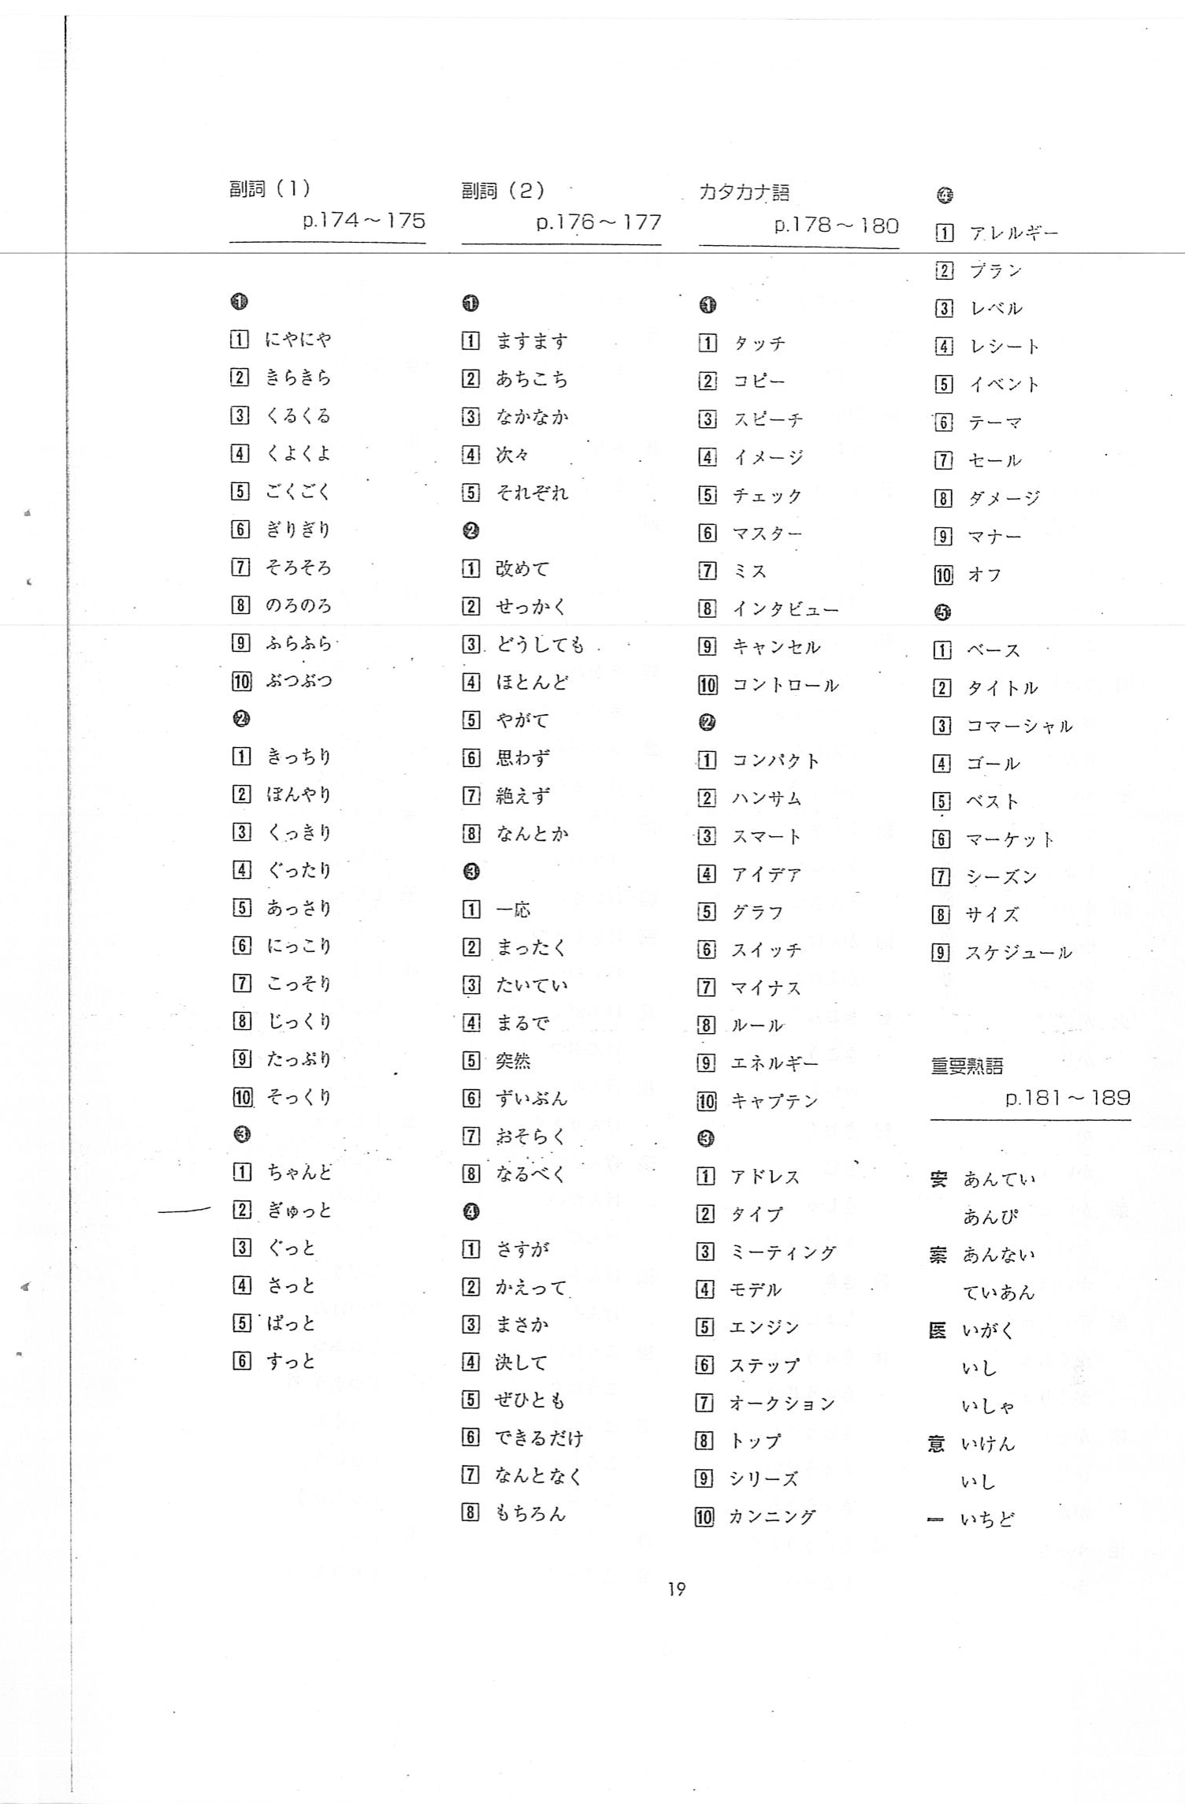

Evaluation Warning : The document was created with Spire.PDF for java.

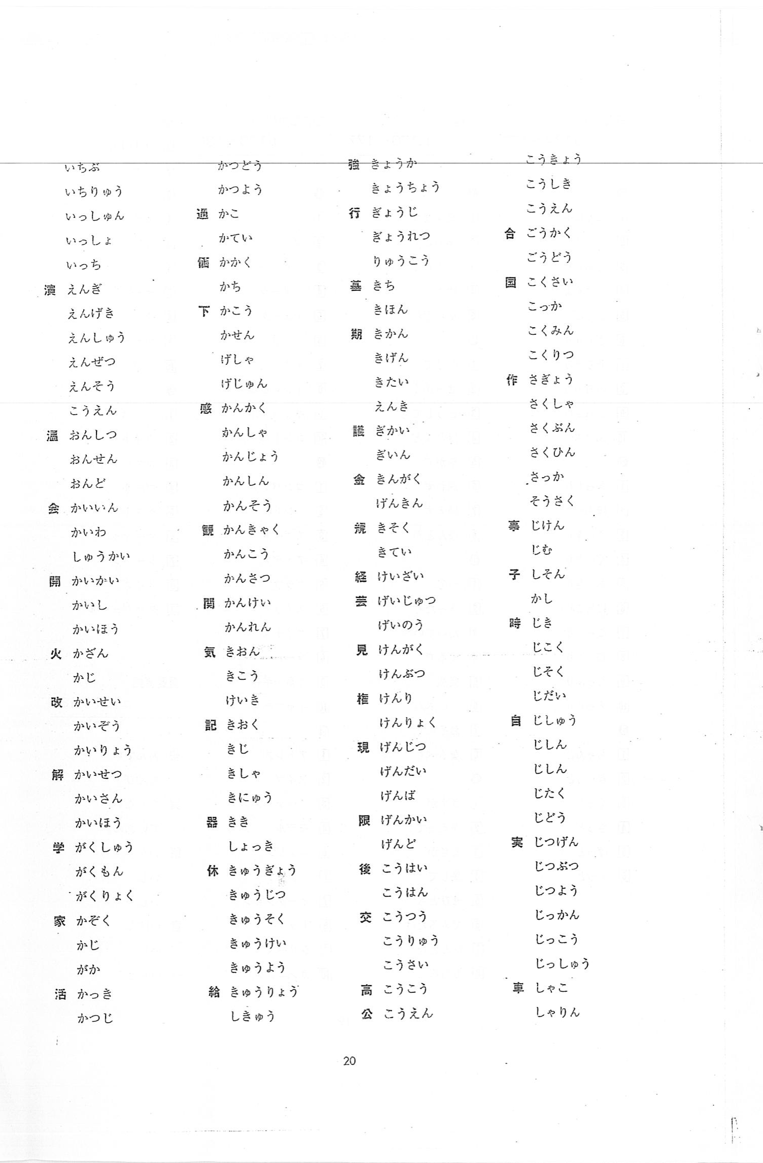

Evaluation Warning : The document was created with Spire.PDF for java.

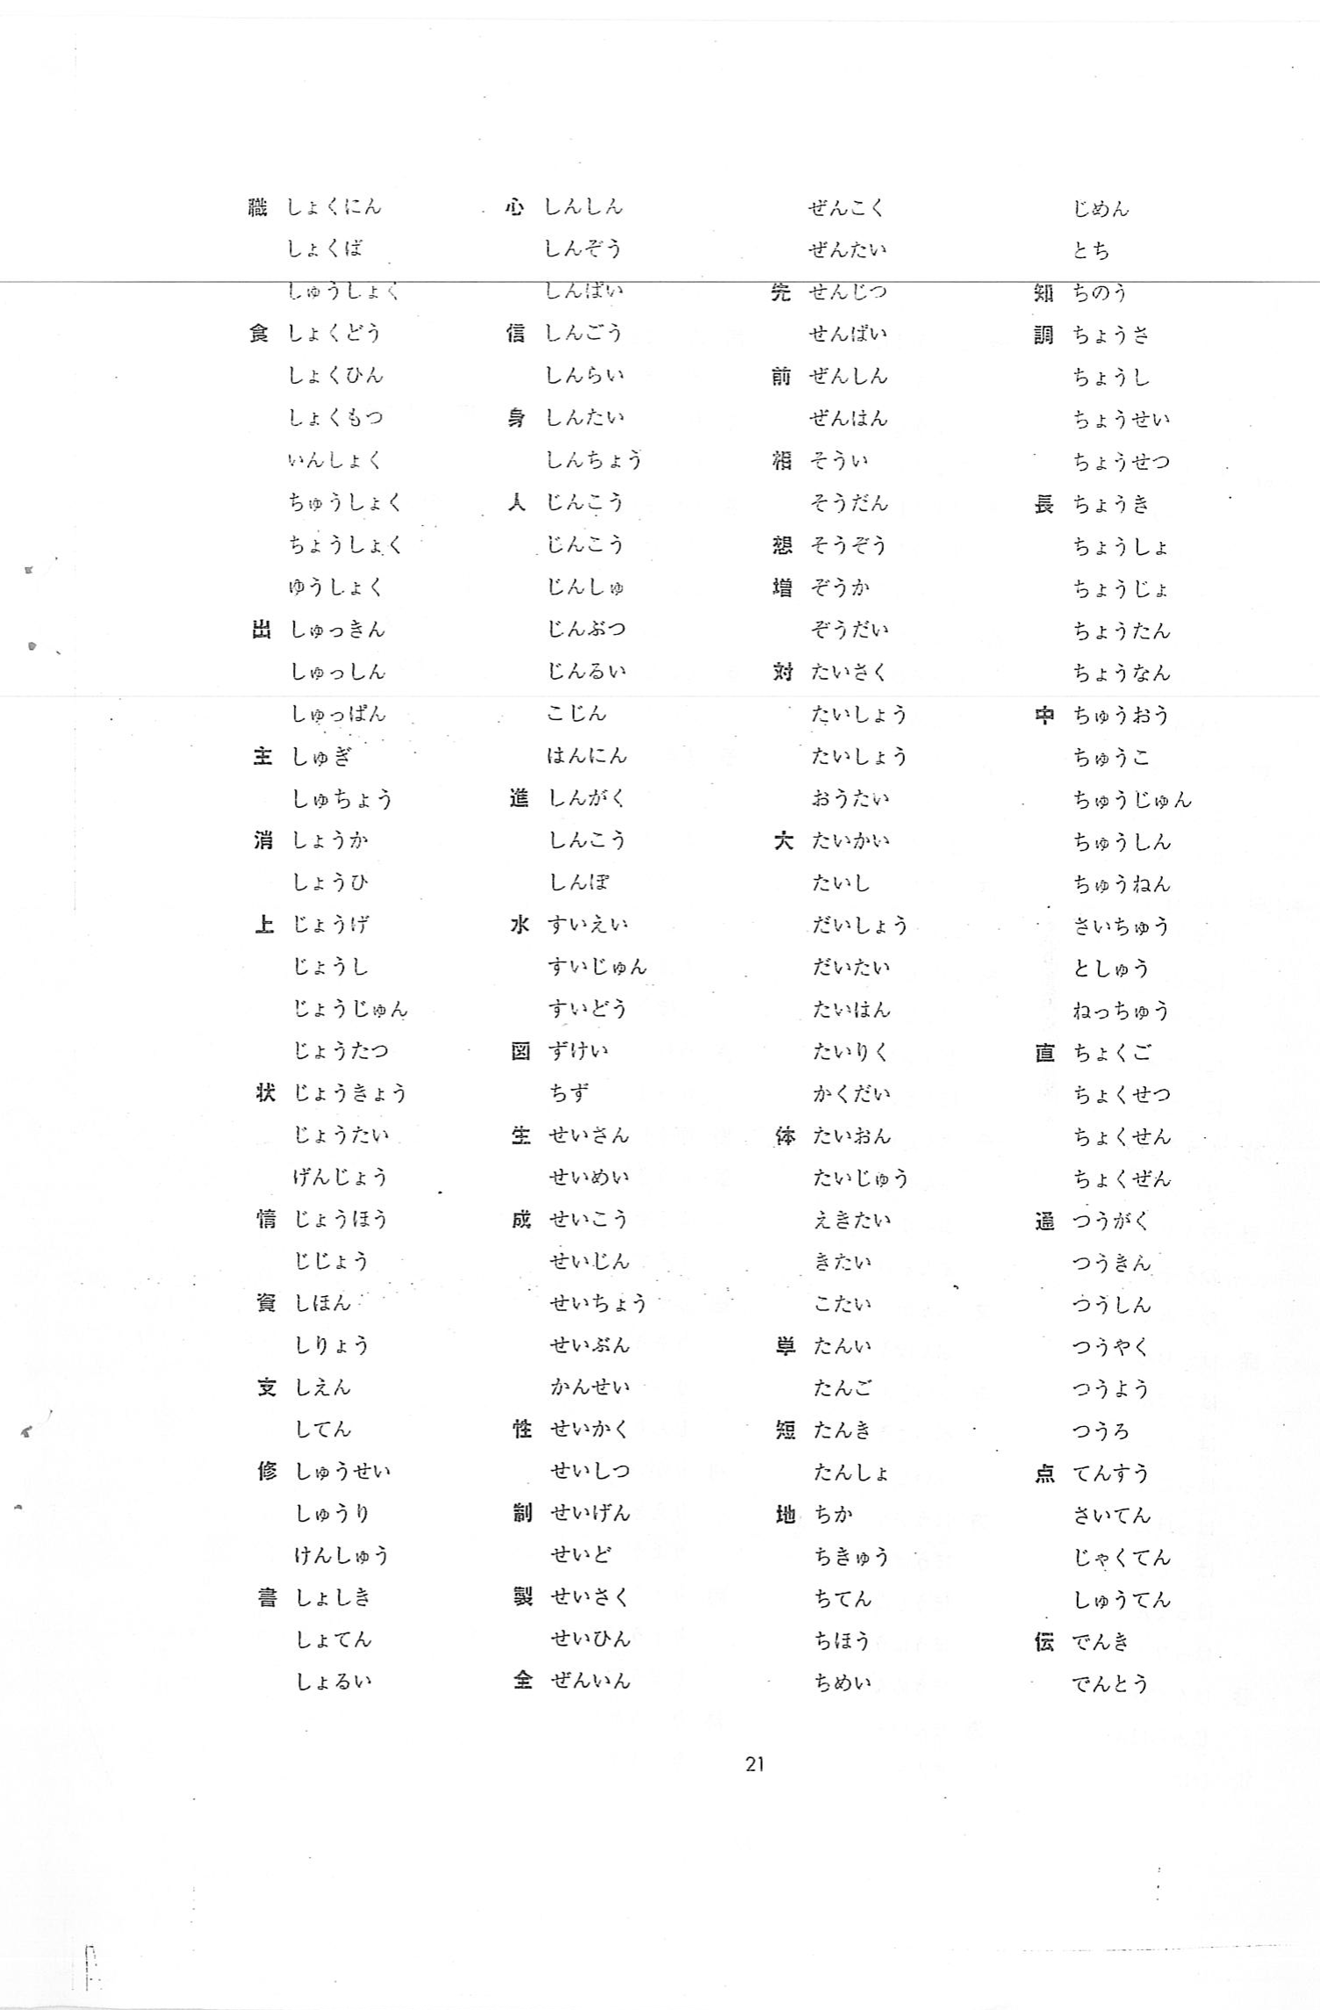

Evaluation Warning : The document was created with Spire.PDF for java.

